POC on extracting logs from AWS Cloud watch using Node.js Script
- Lambda
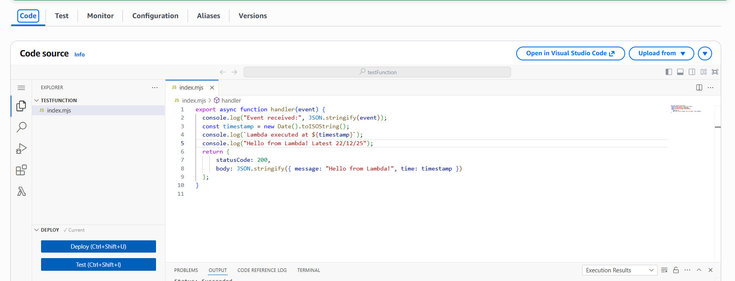
-> Added the role permission to the lambda function to access the cloudwatch logGroup, logStream, logEvents

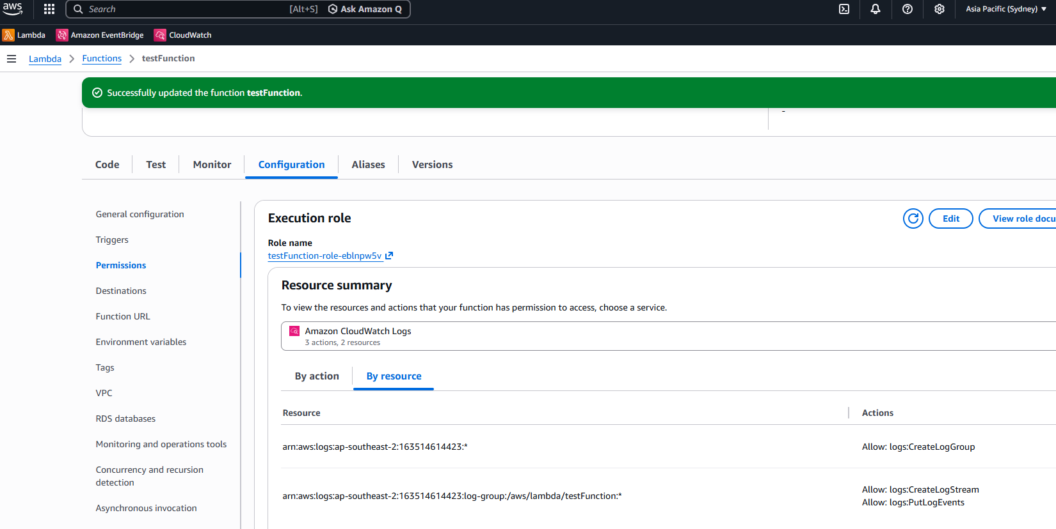
->We get the cloudwatch metrics and can view the logs as shown below:
- Logs SS from cloudwatch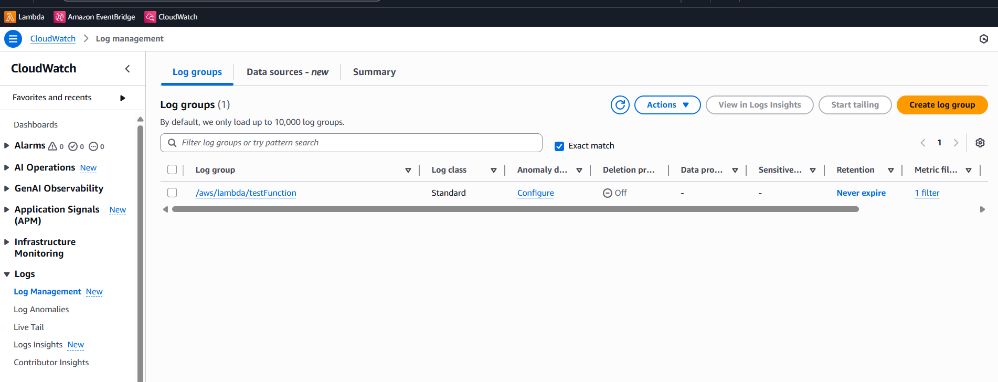
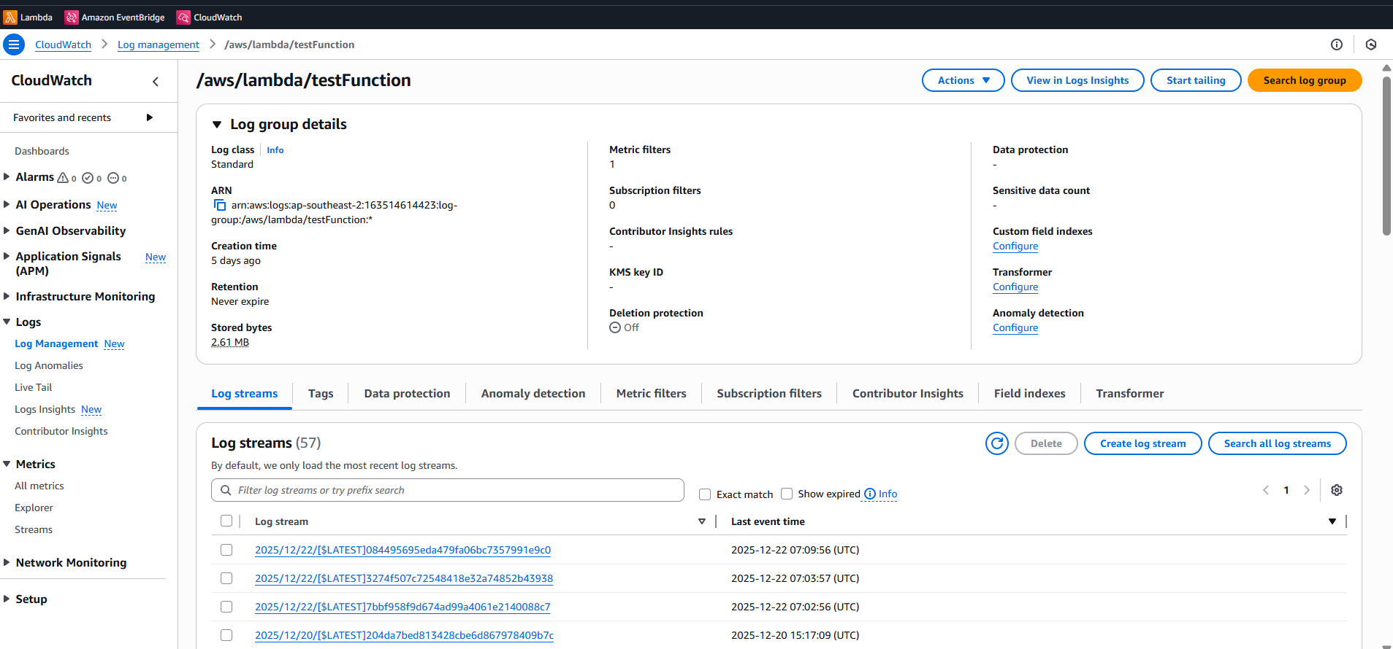
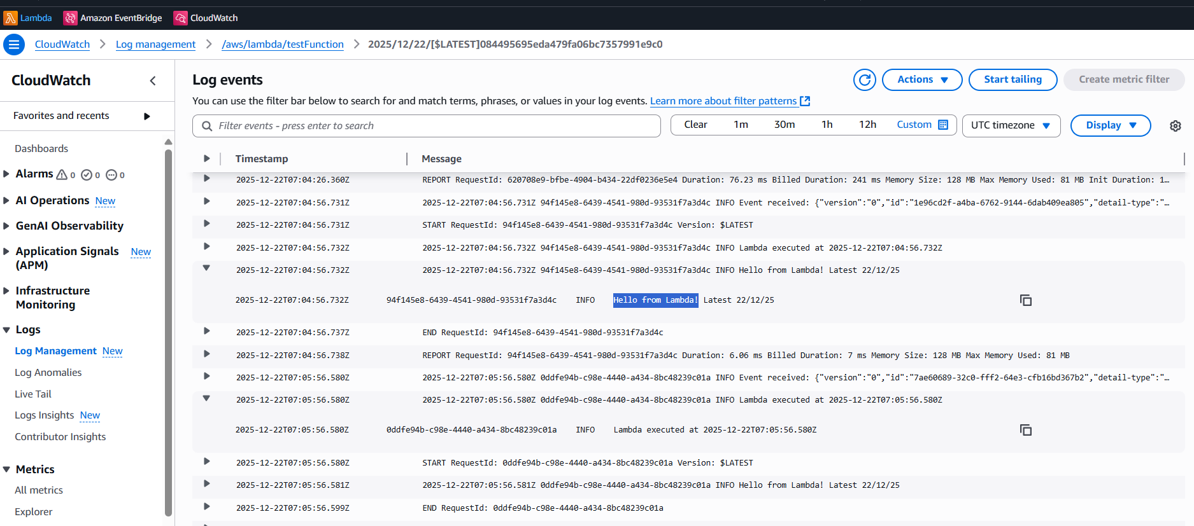

- Code SS VS
-> Installed the dotenv library from nodejs by following the command :
npm install dotenv
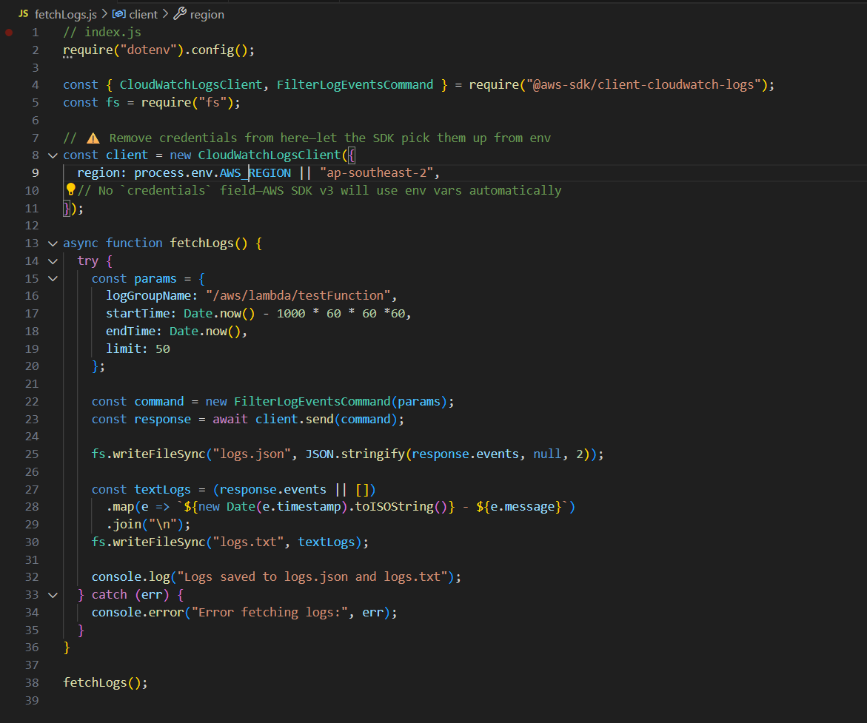
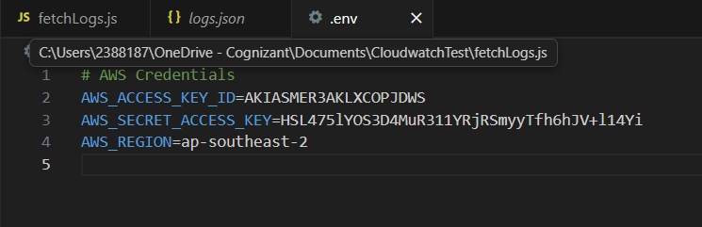

- Log file SS
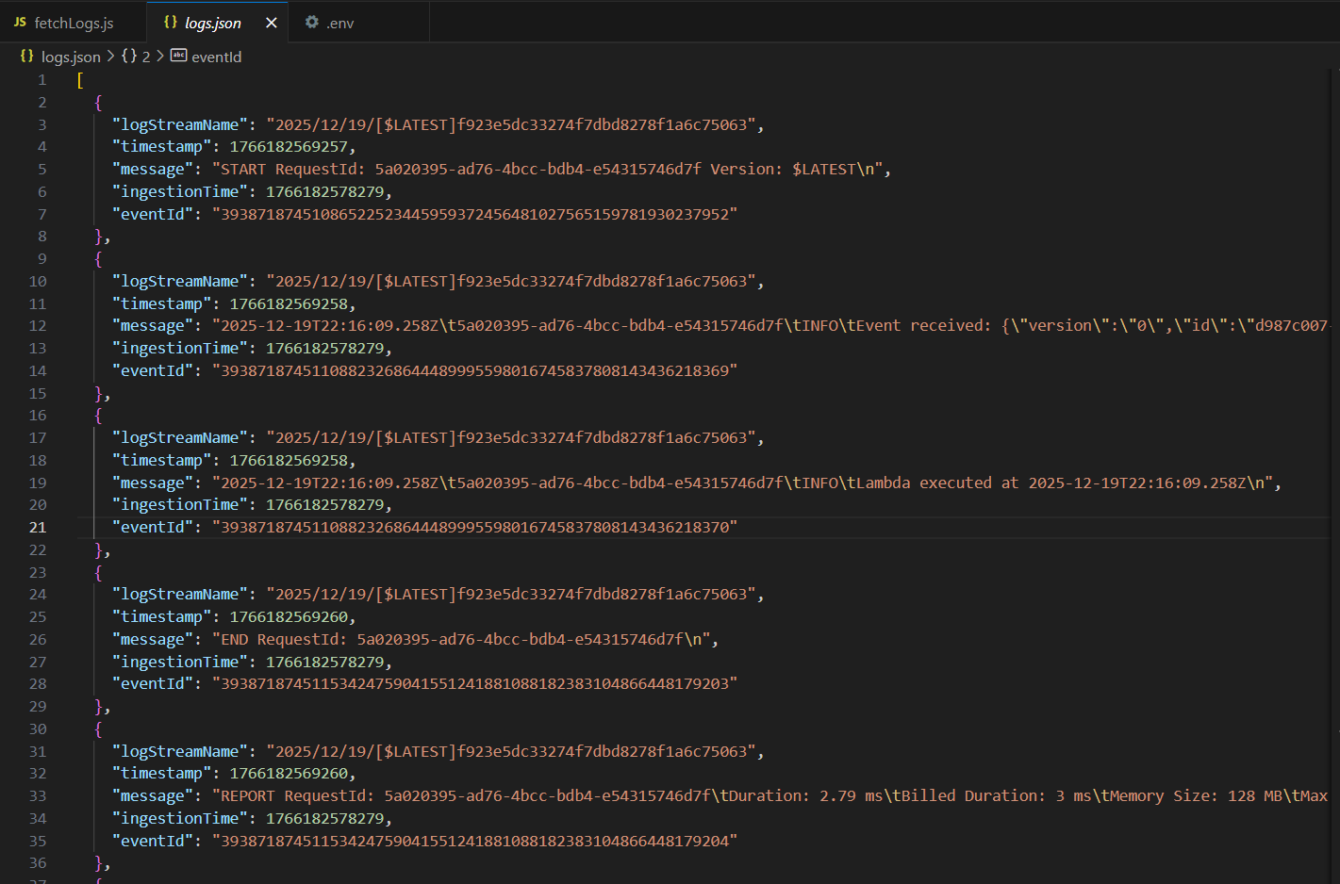

- Descrip – Pre req
-> Cloudwatch: used for monitoring and logging the logs
-> Role: for providing permission access
-> User: Created user with access key and permissions related to cloudwatch
-> Lambda function: consists of events and objects which handles application logs
-> Log management: created log group and get the log streams

